- Open Visual Studio and Select “Open a project or solution”

- Navigate to your “SignalGenUtility-” folder. Within this folder, select the file: “DelsysSigNIalGen.sln”

- Make sure all of the projects are included:
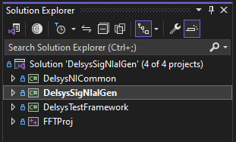

- The file paths included in the code will need to be changed for your local setup.
- For the Transmit side: In ModemProgram.cs, change the ‘test_vals’ path. This path should direct to the folder with the CSVs you will read hr & spo2 data from. This path is referenced in the getNextVals function. The CSVs accessed can either spawn real-time or be pre-existing.
- For the Receive side: In ModemProgram.cs, change the outputLogs path. This will be where .txt files are generated to store logs of what the modem was able to decode. This path is referenced in the GetRecMessagesDataDecode function. In MainViewModel.cs, change the file path for the ‘finalExportedBins’. This path is referenced in the ExportToCSV function. Note: this will only export the points that are saved in memory after the program is stopped. This quantity of points can be specified after opening the program.

- The FFTProj has a lot of dependencies and paths that must be specified. Start by ensuring the FFTProj exists in the same directory as the SignalGenUtility- folder exists in.
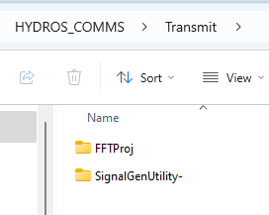

- In the Visual Studio Solution Explorer, right click on ‘FFTProj’. Select ‘Properties’.
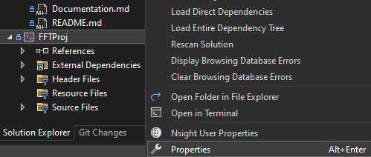

- Under ‘Configuration Properties’ → ‘General’, change the ‘Output Directory’ to YOUR SignalGenUtility- folder followed by \bin\Debug\net8.0-windows.
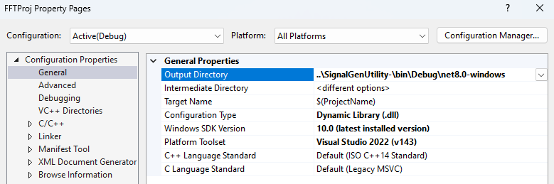
- Still under Configuration Properties, but under C/C++, change the paths for the Additional Include Directories and Additional #using Directories. They should both point to the ‘include’ folder, under your SignalGenUtility- folder.
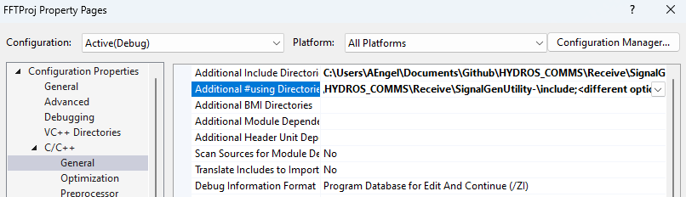
- Still under Configuration Properties, but under Linker, change the path for the Additional Include Directories.
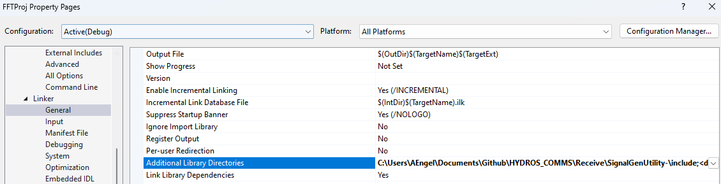

- Under Linker, select “input”. Ensure that the Additional Dependencies .lib files below are specified:
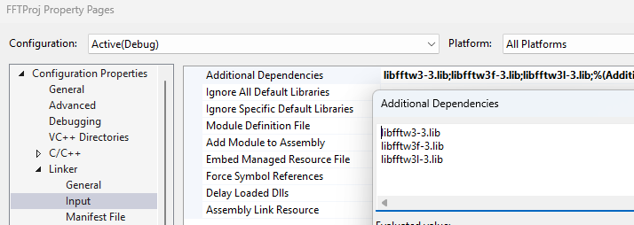

- In a WSL, navigate to your folder containing the popoto_app. For the transmit side, specify the port number as 17000. For the receiving side, specify the port number as 17100.
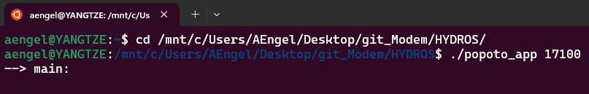

- You should now be able to build and run the program! (There is a different document with info for running the project)
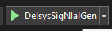
- Some common building problems:
- Anything with the fftw project, often comes from files not being transferred properly. For reference, these are the files I have in the SignalGenUtility-/include folder:
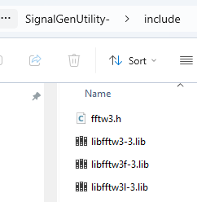
- The are the fftw-relevant files in the SignalGenUtility-/bin/Debug/net8.0-windows folder:
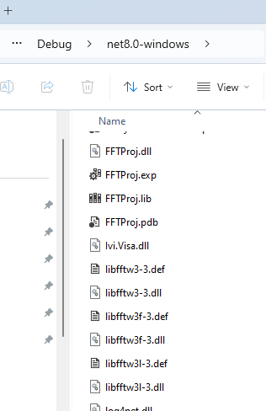
- If any of the above files are missing (other than the Ivi.Visa.dll; that one is unrelated), you can download them from the official fftw website again. Use this website and download the 64-bit version for Windows:
https://www.fftw.org/install/windows.html
- Alternatively, I have put most of the above files in the following locations:
  - U:\Users Common\AnnaE\net8.0-windows
  - U:\Users Common\AnnaE\FFTProj

Please reach out to me, if you have any questions!
- Anna Engel
- AEngel@delsys.com
- anna.c.engel@gmail.com

